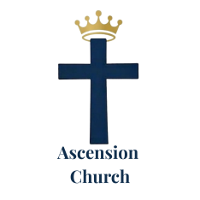
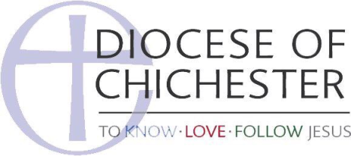

Ascension Church, Haywards Heath
Freely you have received, freely give. Matt 10:8

Complaints Policy and Procedures

The Parochial Church Council (PCC) is committed to its role which primarily includes “cooperation with the minister in promoting in the parish the whole mission of the Church, pastoral, evangelistic, social and ecumenical.” But there may be a time when you need to complain. This complaints procedure is for those who are unhappy about matters for which the PCC is responsible that have affected them.

When responding to complaints, the aim is always to enable them to be resolved informally, speedily and fairly by discussion, problem-solving, mediation and negotiation. Problems should therefore be brought directly to the person(s) responsible for the area of dissatisfaction or disquiet, with the goal of resolving them in this way. The person responsible should be willing to listen, to discuss the matter with the complainant, and to seek to satisfy the concerns where justified.

But if your complaint is about:
Safeguarding of Children or Vulnerable Adults; please use the Safeguarding Policy or speak to the Parish Safeguarding Officer for help and advice.
The Vicar or another minister; please raise the matter with the Vicar. If the matter remains unresolved you could contact the Archdeacon, at Chichester Diocese.
Bullying or Harassment (by adults); you may find it helpful to Use the Diocesan website under Safeguarding then Advice & Getting Help.

Making a complaint to the PCC

If you are dissatisfied with how an informal complaint has been satisfied and wish to make a formal complaint then complaints should be made in writing or by email to the PCC Secretary whose name and contact details are set out below. The PCC Secretary will ensure that your complaint is:
- treated seriously;
- handled fairly without bias or discrimination; and
- treated confidentially.

You should complain within 3 months of the event that you are complaining about. You need to set out:
- your full name and address;
- what you think went wrong and how it has affected you including enough details to show why you are aggrieved; and
- what (if anything) you think the PCC should do to put it right.
If someone else complains on your behalf, the PCC will need written confirmation from you saying that you agree for that person to act for you.

The PCC Secretary will record receipt of the complaint in the complaint log.

How your complaint will be dealt with

The PCC Secretary will write to you or send you an email to confirm receipt of your complaint within 5 working days of its receipt and arrange for it to be considered by the PCC’s Standing Committee. If your complaint refers to particular individuals who are members of the Standing Committee it will meet without them being present.

The PCC’s Standing Committee will look fairly into your complaint including seeking the views on the matter from any individuals, whether members of the PCC or otherwise, to which your complaint refers in order to confirm the facts. The Standing Committee may appoint one or more persons to look into the matter on its behalf but it will be the Standing Committee that makes any decisions. The Standing Committee and any such appointed persons will treat the matter confidentially.

The Standing Committee may invite you to present your complaint to them. If so, you may attend with a friend / representative if you wish. The meeting will be held as informally as possible. The Chair will explain the purpose of the meeting, introduce the members and emphasise confidentiality. The meeting will be minuted by the Committee.

The PCC Secretary will write to you with the conclusions from the PCC Standing Committee’s review and reasons for that outcome. The PCC Secretary will aim to respond to you in this way, as soon as possible and no longer than 6 weeks after the receipt of your complaint.

This will be the PCC’s final response to your complaint.

If you remain dissatisfied, you may wish to consider contacting the Diocese or the Charity Commission, as while Parochial Church Councils are independent bodies they are charities and as such are regulated by the Charity Commission. The Charity Commission and the Diocese can be contacted via their websites.

PCC Secretary
David Cole c/o The Ascension Church, 110 Vale Road, Haywards Heath, West Sussex RH16 4JS, Tel:
07979 840783, email: coledavidg@yahoo.co.uk

Approved 16th June 2026

